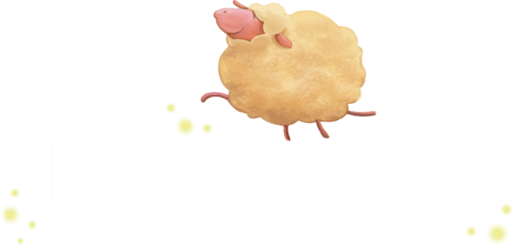

St. Francis Xavier First Reconciliation
2020 Fall Class Schedule

Date | Lesson/Sessions | Video Link
9/13/2020 | Zoom with Ms. Shaun 10 a.m. | Link will be emailed
9/20/2020 | You are Blessed/1.0-1.3 | https://dynamiccatholic.com/blessed/program-view/first-reconciliation/session-1
9/27/2020 | You are Blessed/1.4-1.7  ZOOM 10 AM | https://dynamiccatholic.com/blessed/program-view/first-reconciliation/session-1
10/4/2020 | The Best Version of Yourself/2.0-2.4 | https://dynamiccatholic.com/blessed/program-view/first-reconciliation/session-2
10/11/2020
10/18/2020 | The Best Version of Yourself/2.5-2.7  ZOOM 10 AM | https://dynamiccatholic.com/blessed/program-view/first-reconciliation/session-2
10/25/2020 | God Sent Jesus to Save Us/3.0-3.3 | https://dynamiccatholic.com/blessed/program-view/first-reconciliation/session-3
11/1/2020 | God Sent Jesus to Save Us/3.4-3.7  ZOOM 10 AM | https://dynamiccatholic.com/blessed/program-view/first-reconciliation/session-3
11/8/2020 | Forgiveness and Healing/4.0-4.4 | https://dynamiccatholic.com/blessed/program-view/first-reconciliation/session-4
11/15/2020 | Forgiveness and Healing/4.5-4.7  ZOOM 10 AM | https://dynamiccatholic.com/blessed/program-view/first-reconciliation/session-4
11/22/2020 | Your First Reconciliation/5.0-5.3 | https://dynamiccatholic.com/blessed/program-view/first-reconciliation/session-4
11/29/2020
12/6/2020 | Zoom with Ms. Shaun 10 a.m. | Link will be emailed

