St. Francis Xavier First Reconciliation and First Communion
2019-2020
First Reconciliation  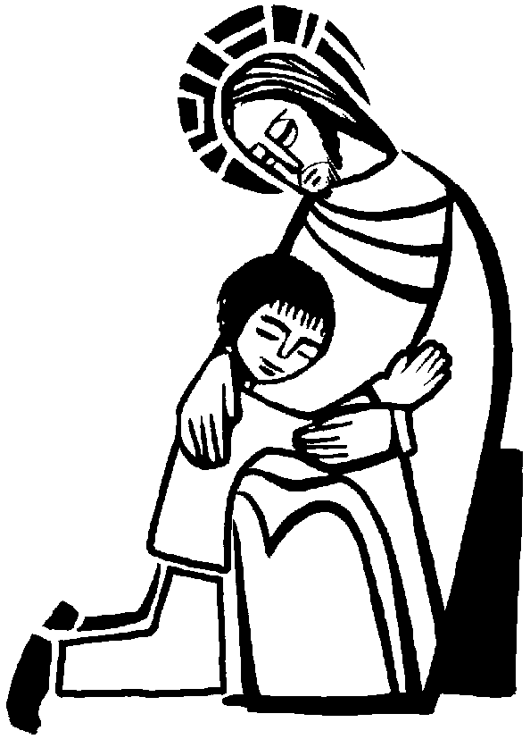 |  |  | First Communion  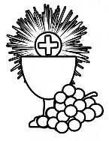
Date | Time/Place | Event | Date | Time/Place | Event
9/22/19 | 9:50-10:30  Parish Hall | F.R. Parent Meeting | 1/12/20 | 9:50-10:30  Parish Hall | F.C. Parent Meeting
9/29/19 | 9:45-10:45  Parish Hall | F.R. Workshop 1 | 1/26/20 | 9:45-10:45  Parish Hall | F.C.  Workshop 1
10/13/19 | 9:45-10:45  Parish Hall | F.R. Workshop 2 | 2/23/20 | 9:45-10:45  Parish Hall | F.C.  Workshop 2
10/26/19 | 10:00  Church | First Reconciliation | 3/15/20 | 9:45-10:45  Parish Hall | F.C.  Workshop 3
 |  |  | 4/25/20 | 9:00-11:00  Church | F.C.  Practice
 |  |  | 5/2/20 | 10:00  Church | First Communion

